Report for the Centre of Sustainable Cropping: December 2020

Detection of Rhizoctonia solani AG-2.1 across the CSC rotation (2011-2019)

Jennie Brierley, Alison Lees, Louise Sullivan and James Lynott
Cell & Molecular Sciences, The James Hutton Institute, Invergowrie, Dundee DD2 5DA
E-mail: Jennie.Brierley@hutton.ac.uk

Introduction

Rhizoctonia solani is a ubiquitous soil-borne saprophytic fungus often referred to as a ‘species complex’. At least 13 anastamosis groups (AGs) of R. solani are known to exist. Rhizoctonia solani has been shown to be pathogenic to a wide range of crops world-wide, often reducing yield and quality. The host range of different AGs varies, for example, R. solani AG3 has a very narrow host range, infecting and causing disease on potato. In contrast, R. solani AG2.1 is known to have a broad host range. For example, R. solani AG2.1 can be pathogenic to potato, but any resulting disease is not usually severe whereas it can be problematic during seedling establishment of brassica species where it is implicated in ‘damping off’, a condition where young root systems rot, resulting in poor crop establishment.

The aim of this work was to investigate the impact of agronomic management practices (conventional versus integrated) for different crops, including potato and soil seed rape (OSR), grown in a six-year rotation at the CSC on R. solani AG2.1 detectable in the soil.

Detection of Rhizoctonia solani AG2.1 in soil sampled from the CSC platform

The CSC platform is based on a six-field rotation (Balruddery Farm, Dundee, Scotland) with individual 5-6 Ha fields planted with potato, winter wheat, beans, spring barley, winter OSR and winter barley each year. One half of each field is managed according to current conventional crop husbandry practice and an integrated management package is applied to the other half. Further details of the design and management treatments can be found at www.hutton.ac.uk/csc
Soil samples were taken in March and November each year from each half field, i.e. conventional and integrated management treatments (2011-2019). A soil sample consisted of a bulk of 100 x 10 g samples taken from across the field area in a W-shape.
Soil DNA extractions were carried out according to the method of Brierley et al. (2009). Target pathogen DNA was quantified using real-time PCR for the detection of Rhizoctonia solani AG2.1 (Budge 2009).
R. solani AG2.1 was detected in 18 of 108 field soil samples taken post-harvest in November (Table 1). There was no apparent effect of the management treatments on detection of R. solani AG2.1, with ten positive samples originating from integrated field treatments and eight from conventionally managed treatments. Of the 18 AG 2.1 positive samples, a greater proportion were from fields which had grown potato and OSR (6 and 5 respectively) compared with other crops (Table 1).

Table 1. Crops planted across the six diﬀerent experimental ﬁelds in 2011−2019. Year corresponds to the year in which the crop was harvested. Winter wheat, Winter barley and Winter OSR are planted in the preceding year. Blue shaded cells indicate that R. solani AG2.1 was detected in soil samples taken in November (post-harvest. Each field is split in two, with one half managed conventionally (C) and the other half with an integrated (I) approach.
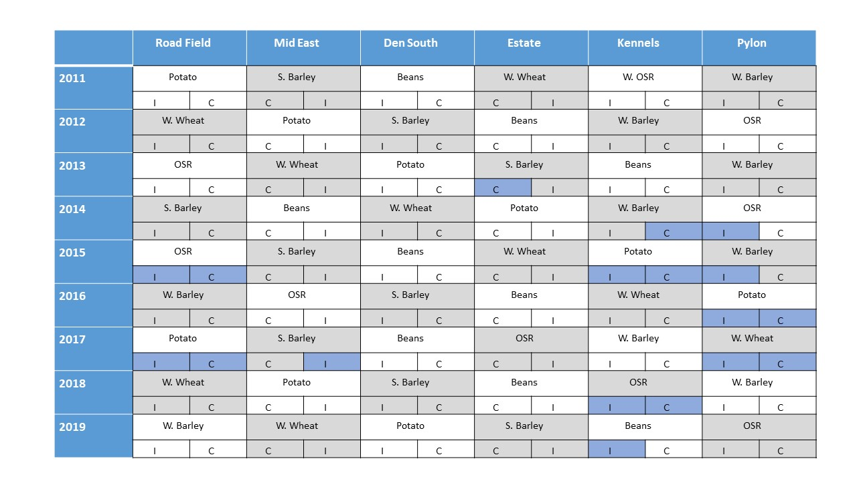
Table 2 shows detection of R. solani AG2.1 through a set of four time points, focussing on fields planted with OSR; March - previous crop, November – early establishment of OSR, March – later establishment of OSR and November - post harvest. There was only one occasion when R. solani AG2.1 was detected in March before an OSR crop was planted. In four out of the nine years, R. solani AG2.1 was detected in at least one of the field treatments (C or I) in the soil sampled in March during OSR establishment. In these fields, inoculum was generally also detected the following November post- harvest. There was no effect of the two management practices on detection of R. solani AG2.1 at any time point.

The number of stems was recorded prior to harvest between 2012-2017. Although there were differences between years, there was no evidence that high levels of R. solani AG2.1 detected in the establishing OSR crop lead to fewer stems or decreased yield (Table 2).

Table 2. Rhizoctonia solani AG2.1 detected in field soil; before, during and after cropping with OSR: March previous crop, November early establishment, March later establishment, and November post-harvest.
Year | Field | Manage-ment treatment | AG2.1 ª March -previous crop | AG2.1 ª November- early establishment | AG2.1 ª  March  Later establishment | AG2.1 ª November - post harvest | Number of stems^{b} (m²) | Mean yield  (t ha)
2010/11 | Kennels | I | * | * | 0 | 0 |  | 2.40
 |  | C | * | * | 0 | 0 |  | 3.77
2011/12 | Pylon | I | 0 | * | 0 | 0 | 49.0 | 2.10
 |  | C | 0 | * | 0 | 0 | 43.5 | 2.06
2012/13 | Road Field | I | 0 | 0 | 0 | 0 | 60.2 | 1.62
 |  | C | 0 | 0 | 0 | 0 | 46.7 | 3.94
2013/14 | Pylon | I | 0 | 0 | 6,114 | 105 | 88.0 | 3.04
 |  | C | 0 | 0 | 0 | 0 | 65.7 | 2.87
2014/15 | Road Field | I | 0 | 0 | 0 | 43,068 | 56.9 | 4.05
 |  | C | 0 | 0 | 161 | 770 | 53.9 | 3.68
2015/16 | Mid-East | I | 0 | 0 | 0 | 0 | 64.0 | 3.96
 |  | C | 0 | 0 | 0 | 0 | 66.6 | 4.13
2016/17 | Estate | I | 0 | 0 | 0 | 0 | 33.5 | 2.58
 |  | C | 0 | 0 | 0 | 0 | 30.6 | 4.55
2017/18 | Kennels | I | 0 | 0 | 603 | 5,159 |  | 2.42
 |  | C | 0 | 0 | 100 | 363 |  | 2.51
2018/19 | Pylon | I | 5,557 | 0 | 1,249 | 0 |  | 2.64
 |  | C | 0 | 0 | 233 | 0 |  | 4.19
ª Soil inoculum is measured as R. solani AG2.1 pg DNA/g soil; ^{b} Stem numbers; average across all varieties and corrected for differences in sowing density between I and C treatments.
A. healthy OSR root from a seedling grown in a control pot and B. pruned OSR root of a seeding grown in compost inoculated with R. solani AG2.1
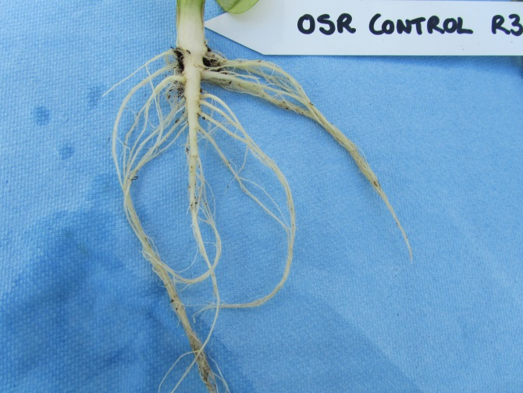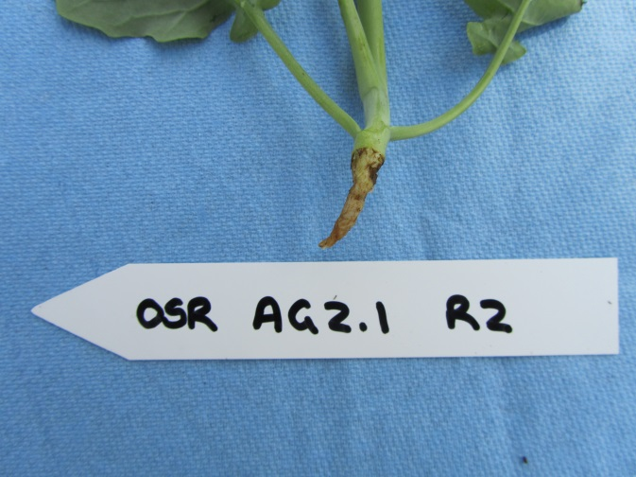
A.
B.

Comment and Conclusion
In this study we demonstrated that R. solani AG2.1 can be detected in field soil, and that within the rotation studied (CSC), it was more prevalent in potato and OSR crops than barley, wheat and beans. In the CSC rotation, OSR did not follow potato, nor potato follow OSR, either of which may have potentially increased the risk of R. solani AG2.1 increasing in the soil. There was evidence that the pathogen could persist in the soil. When inoculum was detected in the establishing OSR crop, it was generally also detected in November, following harvest. However, there was no indication of longer-term persistence, as illustrated by the near absence of detection of R. solani AG2.1 in the field sampled before OSR was planted.
Although not demonstrated here, additional work shows that R. solani AG2.1 is pathogenic to crops such as OSR, carrot, sugar beet and broccoli. This therefore highlights the importance of the sequence of crops within a rotation to reduce disease pressure resulting from soil-borne pathogens such as R. solani AG2.1.

References
Brierley JL, Stewart JA, Lees AK. 2009. Quantifying potato pathogen DNA in soil. Applied Soil Ecology 41, 234-8.
Budge GE, Shaw MW, Colyer A, Pietravalle S, Boonham N. 2009. Molecular tools to investigate Rhizoctonia solani distribution in soil. Plant Pathology 58, 1071–1080

The work presented here was funded by the Scottish Government’s Rural and Environment Science and Analytical Services (RESAS) Division.

